- Open the OnDeck App on your smart device and log in.
- Select the 3 white bars in the upper left hand corner.
- Under Events, Select Events & Meet Entries.
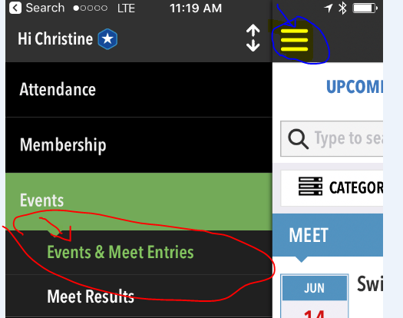
- Select Commitment Under the appropriate Swim Meet Event.
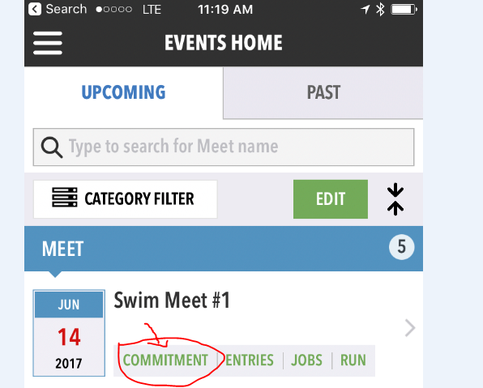
- Select your appropriate Undeclared member.
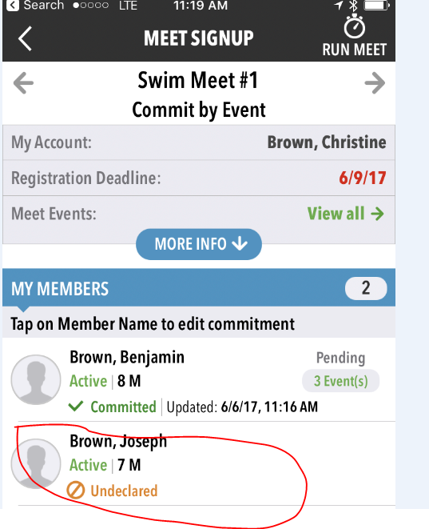
- Either Say No Thanks to signing-up for the event , or select Yes, please if they are swimming in the meet.
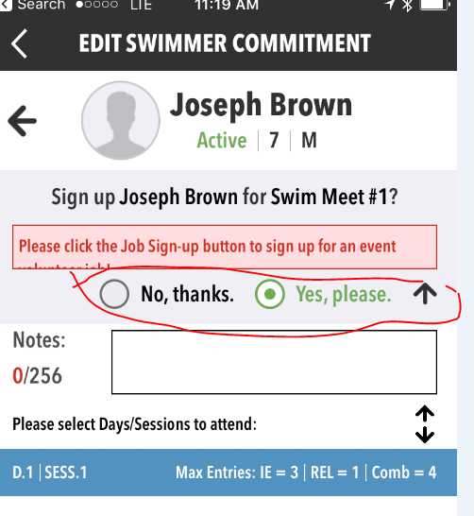
- Select the Blue Bar to show the eligible events. Select up to 3 for your swimmer. Pay close attention to the Age you are selecting.
Key: FR = Freestyle Stroke
BK = Back Stroke
FL = Butterfly Stroke
BR = Breast Stroke
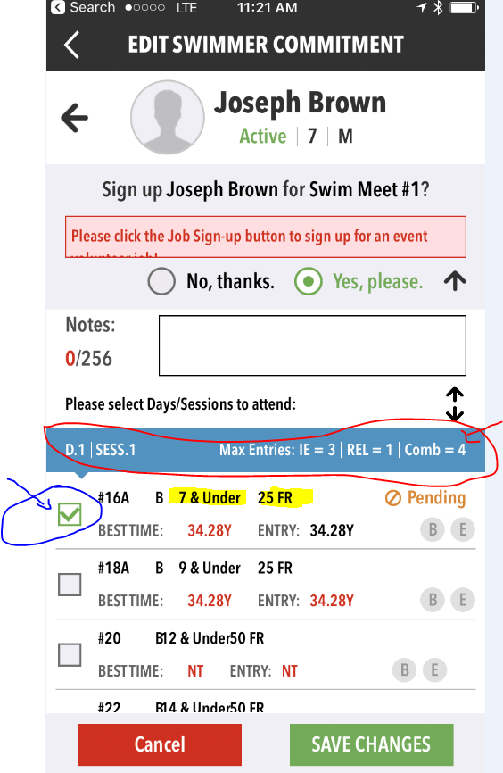
- You are done!
